Ideation Phase
Empathize & Discover
Date | 21 October 2026
Team ID
Project Name | Incident Lifecycle Automation in ServiceNow
Maximum Marks | 4 Marks

Empathy Map Canvas:
An empathy map is a one-page visual that records what a user thinks, feels, hears, sees, says and does, along with the pains they face and the gains they want. It helps the team look at the problem from the user’s point of view before a solution is designed.
In this project, the empathy map is built around the Service Desk Agent, the person who records, classifies, assigns, investigates and resolves incidents in ServiceNow. Understanding what this person experiences each day shows where the incident lifecycle breaks down and where automation can help most.
User Profile:
Role | Service Desk Agent handling incoming IT incidents
Goal | Move each incident from creation to closure quickly, correctly and with complete records
Main challenge | Incomplete details, unclear ownership, repeated troubleshooting and difficulty tracking SLAs
Daily tasks | Recording incidents, classifying them, assigning groups, searching knowledge, updating work notes and closing incidents
Works with | Callers and employees, resolver groups, knowledge articles, change requests and managers
Success looks like | The right group assigned first time, known fixes reused and a clear resolution recorded

Example Scenario:
An employee reports that they cannot connect to the corporate VPN. The agent records the issue, asks for the category and urgency, and assigns the incident to the network support group. The agent then searches knowledge articles for a known fix, links any related incident, watches the SLA timer and records the resolution when the incident is closed.
Each of these steps is a point where details can be missed, ownership can become unclear or work can be repeated. These points are what the empathy map captures.

Empathy Map: Incident Lifecycle Automation in ServiceNow
User: Service Desk Agent
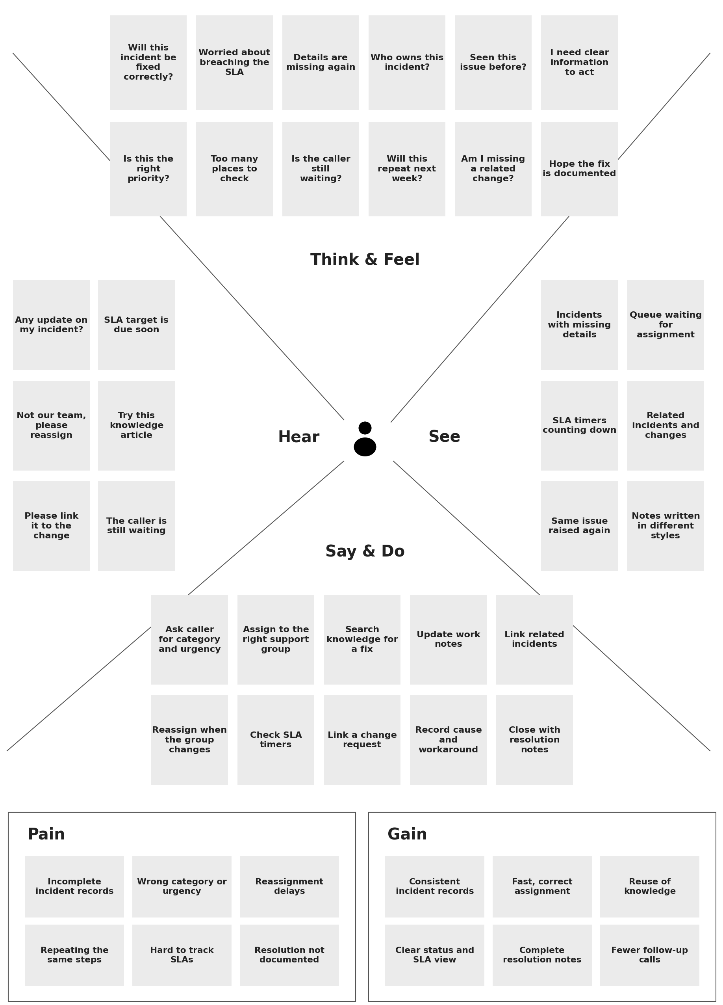

Key Insights from the Empathy Map:
The table below links what the Service Desk Agent experiences to what the incident lifecycle automation should provide.
Area | What the agent experiences | What the project should provide
Incident recording | Details are missing or written differently each time | Clear fields so every incident has the information needed to start work
Classification | Category, urgency and service are chosen inconsistently | Consistent classification using category, subcategory, urgency, service and configuration item
Assignment | Incidents are reassigned and ownership is unclear | Routing to the correct support group with a clear owner
Investigation | The same troubleshooting is repeated for similar issues | Easy access to knowledge articles and related incidents
Change handling | Related changes are hard to connect to an incident | Linking a change request when a change is needed to resolve the incident
Related incidents | Similar incidents are handled separately | Parent–child links between related incidents
SLA tracking | SLA timers are hard to watch across many incidents | Visible SLA information on the incident and its tasks
Resolution | Resolution details are skipped or incomplete at closure | Recorded cause, workaround, work notes and resolution for future reference

Key Takeaways:
- The agent’s biggest worry is acting on incomplete information, so the first step of the lifecycle needs to capture the right details.
- Unclear ownership and reassignment cause delays, which makes accurate assignment a high priority.
- Repeated troubleshooting wastes time, so knowledge articles and related incidents should be easy to find and reuse.
- SLA status needs to be visible at a glance so the agent can act before a target is missed.
- A complete resolution record at closure helps future incidents and reduces follow-up calls.

How This Supports the Project:
The empathy map shows that problems occur at every stage of the incident lifecycle, not in one place. The ServiceNow implementation therefore focuses on the full path from recording and classification through assignment, investigation, resolution and SLA tracking, so that the agent can work with less confusion and fewer repeated steps.

